March 13, 2024
Ref: IIH/MD/2024/03/015

The Secretary to the State Government (SSG),
Governor’s Office,
Ahmadu Bello Way,
GRA, Ilorin, Kwara State

Dear Sir,
REIMBURSEMENT OF EXPENSES INCURRED IN FEBRUARY 2024
I write to request for the processing of the reimbursement for funds spent during the month of February 2024 in the course of assignments given by His Excellency. I have attached the approvals for these expenses.

A breakdown of costs is given below:

SN |  | Amount
1 | Costs Incurred during visit of delegation from Deputy High Commission of Canada on Trade Visit to Kwara State | 540,000
2 | Costs Incurred for Site Survey of NSIA Diagnostic Center in Harmony Advanced Diagnostic Center Complex | 300,000
 | Sub-Total | 840,000
 | Total | 840,000

Yours sincerely,
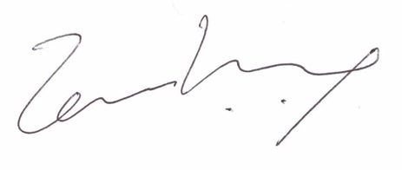
Temi Kolawole
ag. Managing Director

